**To those responsible for submitting the DORA RoI via the Central Bank of Ireland Portal between 1st and 4th April 2025:**

The submission of DORA RoIs is now only six days away. The Central Bank of Ireland has tested its system and a sample of RoIs have successfully been uploaded. We are therefore ready to accept the RoI submissions.

Based on testing performed, we are aware that RoIs will fail to be uploaded successfully to the Central Bank of Ireland Portal if basic steps have not been followed by those responsible for submitting the RoI. *We therefore recap in this communication the key links to be followed for guidance, while also sharing a list of common mistakes that firms may inadvertently make.*

Please note that the Central Bank of Ireland will not troubleshoot issues within reporting packages. Our support teams will only be on hand to support issues with the Central Bank of Ireland systems as part of the submission process. We encourage firms to frontload their initial submission early in the 1st- 4th April window such that there is time for the firm to remediate any issues.

Furthermore, we want to emphasize the importance of following the relevant EU level guidance for compiling your register packages to meet your compliance requirements.

* The guidance provided on the EBA preparation site in the section on ‘PREPARATIONS FOR OFFICIAL REPORTING OF REGISTERS’, in particular the **slides** on [preparing the reporting package](https://eba.europa.eu/sites/default/files/2025-01/1e5ffe22-64b2-4260-8fbf-8dcf095dfe4b/Preparing%20Plain%20csv%20reporting%20package%20for%20DORA.pdf)  provide useful information.
* The ESAs confirmed in their December workshop (which is recorded and available on the European Banking Authority’s (EBA) [register preparation site](https://eba.europa.eu/activities/direct-supervision-and-oversight/digital-operational-resilience-act/preparation-dora-application)) that a template or conversion tool **would not be provided** for the official submission.
* Financial entities must compile their RoI reporting package following the details in the [ITS on the RoI](https://eur-lex.europa.eu/eli/reg_impl/2024/2956/oj/eng), noting any clarifications in the ESAs RoI FAQ on their preparation site (linked above) and also any corrections to the ITS in the [ESAs DORA QAs](https://www.esma.europa.eu/joint-committee/joint-qas).
* On that [register preparation site](https://eba.europa.eu/activities/direct-supervision-and-oversight/digital-operational-resilience-act/preparation-dora-application), the ESAs also provide many other useful materials for financial entities preparing their RoI including but not limited to:
  + Examples of what your compiled registers should look like - **sample files for taxonomy 2.0** (note that you should view the "Excel"- files within these packages through notepad to see the correct formatting - e.g. date format shows incorrectly if you open those files with Excel);
  + Lists of possible entries in the drop down fields in the file;
  + Also in terms of how each csv should be structured, the [DPM dictionary](https://www.eba.europa.eu/sites/default/files/2025-03/84dc8ed3-8982-45cf-8b91-6d019f88ec92/dpm2_4_0_glossary_20250129.xlsx) and [DPM table layout and data point categorization](https://www.eba.europa.eu/sites/default/files/2024-12/7ae0363a-ad3d-42d9-a192-34711416c039/annotated_templates.zip) on the same EBA preparation website guides entities and their vendors as to what should be in each of the files;
  + Further documentation on the overall EBA reporting framework 4.0 is also available: <https://www.eba.europa.eu/risk-and-data-analysis/reporting-frameworks/reporting-framework-40>; and
  + When the xBRL OIM-CSV reporting package is fully prepared and checked by you, it should be saved as a .zip file. In the screen for uploading your reporting package in the CBI Portal there is further information on the naming requirements for the reporting package to be submitted. More information on the upload process can be found in the [system guide](https://www.centralbank.ie/regulation/digital-operational-resilience-act-dora/reporting-registers-of-information) on how to upload your prepared RoI to the Central Bank Portal.

Some common mistakes in uploading DORA Register files encountered through testing can be remediated by ensuring you have checked the following:

* Ensure there are **no spaces in the filename** – may look fine at a quick glance, but on closer inspection spaces in the filename have been detected which will prevent the file from uploading;
* Ensure the **date format** within the files is correct – i.e. **YYYY-MM-DD**. We have noticed that a lot of firms seem to have YYYY/MM/DD or DD-MM-YYYY by mistake;
* Ensure you have ‘.CON’ or ‘.IND’ after your LEI code in the *parameters* file, depending on whether you are submitting a consolidated register or an individual, entity-level register, and ensure there is ‘rs:’ in front of it e.g.

|  |  |
| --- | --- |
| entityID | rs:1234567A1XYZSTUV6789.IND |

Or

|  |  |
| --- | --- |
| entityID | rs:1234567A1XYZSTUV6789.CON |

* Make sure you are using the **current taxonomy 4.0 schema** in the reports.json file;
* Ensure there are **no currency symbols (e.g. € $ etc)** in the cells for monetary values;
* Ensure reference date is 31 March 2025 (**ref period ,2025-03-31**);
* Ensure that you don't have duplicate columns in any of the reporting files;
* Ensure that your columns follow the correct sequence.

The compiled file should have the following structure prior to submitting to Central Back of Ireland:

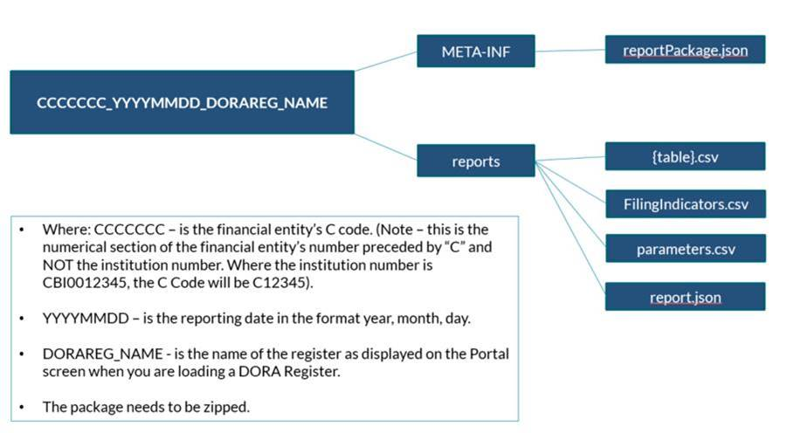

This is what the compiled file should look like (example with a test firm C#):

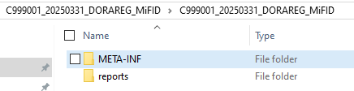

The META-INF folder should then contain:

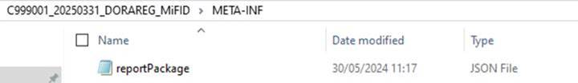

And the reports folder would look like the following:

