Guidance Note on Submitting an Application for Authorisation as a Retail Intermediary via the Online Reporting System

Applicable to applications for authorisation under the:
Investment Intermediaries Act 1995 (IIA)
European Union (Insurance Distribution) Regulations 2018 (IDR)
European Union (Consumer Mortgage Credit Agreements) Regulations 2016 (CMCAR)
Consumer Credit Act 1995 (CCA)
October 2018

Table of Contents

PART 1 - Notes on Completion 3
Terms used in this Guidance Note 3
General Notes 4
PART 2 – Guidance on Submitting an Application for Authorisation as Retail Intermediary via the ONR 5
Introduction 5
1. Login to the ONR 5
2. Access the Retail Intermediaries Application 6
3. Create a Return 7
4. Upload the Application Form and the Relevant Supporting Documentation 9
5. Submit the Completed Return 11
6. List of Statuses 13

PART 1 - Notes on Completion

Terms used in this Guidance Note
Central Bank Central Bank of Ireland

Applicant The person (i.e., the natural or legal person) making an Application Submission to the Central Bank seeking authorisation as a retail intermediary

Authorisation Authorisation or registration, as appropriate in terms of the relevant legislation under which the applicant is seeking authorisation as a retail intermediary

Application Submission An Application Form and all required supporting documentation, including but not limited to, fully completed Individual Questionnaires and Garda Vetting Forms (where relevant)

Application Form A fully completed and signed “Application Form for Authorisation as a Retail Intermediary” including the specific information and documentation requested therein i.e., including a fully completed Document Checklist, Declaration and Annex 1 (where relevant)

IIA Investment Intermediaries Act 1995

IDR European Union (Insurance Distribution) Regulations 2018

CMCAR European Union (Consumer Mortgage Credit Agreements) Regulations 2016

CCA Consumer Credit Act 1995

IQ Individual Questionnaire

ONR Online Reporting System

PCF Pre-Approval Controlled Function within the meaning of Schedule 2 of the Central Bank Reform Act 2010

Retail Intermediary An investment intermediary within the meaning of the IIA, an insurance intermediary, ancillary insurance intermediary or reinsurance intermediary within the meaning of the IDR, a mortgage credit intermediary within the meaning of the CMCAR and/or a mortgage intermediary within the meaning of the CCA

General Notes
There are 3 methods by which an Applicant can submit an Application Form to the Central Bank:
- The Applicant can request login details to the ONR. Once it has received login details, the Applicant can login to the ONR and upload the relevant documentation associated with the Application Form; or
- The Application Form can be sent directly by post and email; or
- The Application Form can be sent directly by post with a soft copy enclosed.

- For option 1 login details will be provided within 5 working days. This Guidance Note provides guidance to applicants in relation to submitting a completed Application Form via the Central Bank’s ONR.
- For options 2 or 3 above, please note that a physical copy and an electronic copy (e.g., memory stick/flash drive, CD etc.) of the completed Application Form should be submitted to the Central Bank. See more details on the Central Bank website here. The paper copy should be sent to Retail Intermediaries Authorisations Team, Consumer Protection: Policy and Authorisations, Central Bank of Ireland, PO Box 559, New Wapping Street, North Wall Quay, Dublin 1, D01F7X3 and the electronic version can be included with the hard copy or sent by email to RIAuthorisations@centralbank.ie.

If the applicant has any queries in relation to this Guidance Note or the application process, please email them to RIAuthorisations@centralbank.ie

PART 2 – Guidance on Submitting an Application for Authorisation as Retail Intermediary via the ONR

Introduction
If an applicant wishes to submit an Application Form via the Central Bank’s ONR, it must first request log-on details by email from RIAuthorisations@centralbank.ie. On receipt of a request, the RetaiI Intermediary Authorisations Section will arrange for the Central Bank’s Regulatory Transactions Division (RTD) to issue log-on details and a link to the ONR to the applicant.
In submitting an Application Form via the ONR, the applicant will be required to complete the following steps:
(1) Login to the ONR;
(2) Access the Retail Intermediaries Application;
(3) Create a Return;
(4) Upload the Application Form and the relevant supporting documentation requested therein; and
(5) Submit the completed Return.
The sections below provide guidance to applicants in relation to completing these steps.

Login to the ONR
  - Applicants must use the login username and password provided by RTD to access the Central Bank’s ONR.
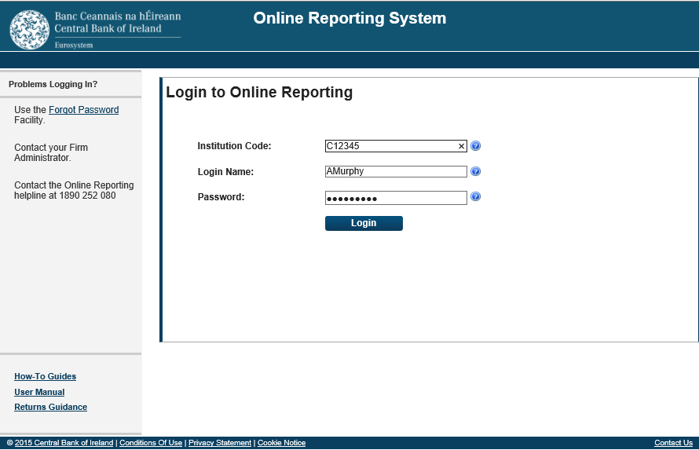

Access the Retail Intermediaries Application
  - On entering the log-on details via the link to the ONR received from RTD, the applicant will be on the ONR ‘Home Page’. See Figure 1 below. The applicant should note the additional guidance notes available on the left hand side of the screen (and on all subsequent screens).

Figure 1
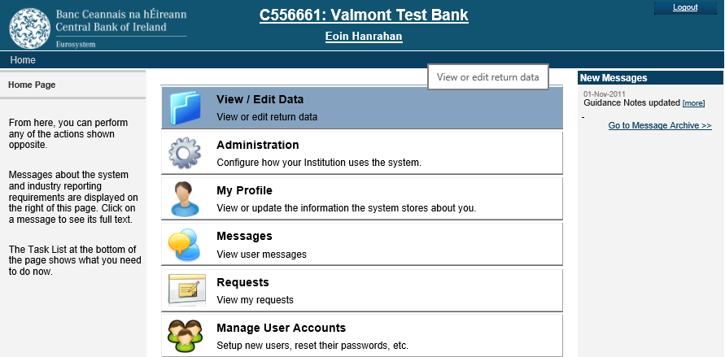

  - Click on ‘View/Edit Data’ at the top of the screen to bring you into the ‘Return Types’ page.

Create a Return
3.1 In the ‘Return Types’ page, scroll down to ‘Retail Intermediaries’ and click on ‘Retail Intermediaries Online Application’. See Figure 2 below.
Figure 2
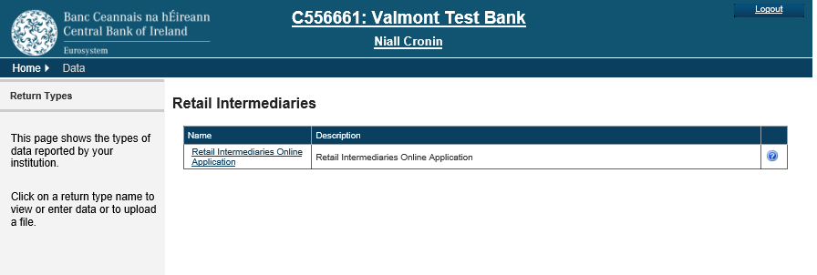
  - In the ‘Retail Intermediaries Online Application’ page, click on ‘View/Edit Returns’ and then ‘Add Return’ on the bottom right hand side of the screen. See Figures 3 and 4 below.

Figure 3
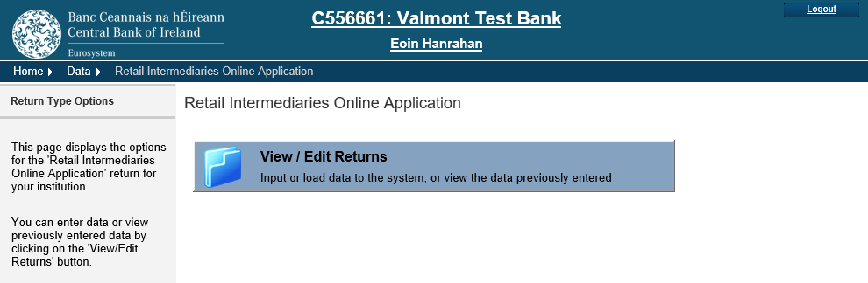

Figure 4
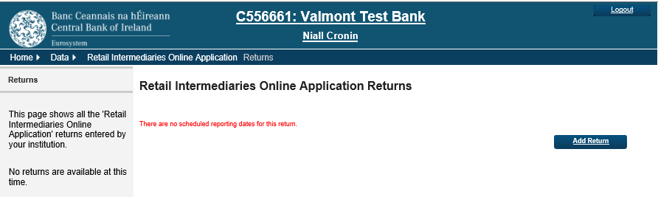

  - In the ‘Add Return Instance’ page, follow the instructions on the left hand side of the screen regarding the dates to be entered for the ‘Reporting Date’ and ‘Submission Due Date’ and click ‘Add’, see Figure 5 below. Use the calendars provided when you click on the right of the input boxes. The Submission Due Date will automatically default to 4 weeks from the Reporting Date i.e., in this example, the Reporting Date is 09-Oct-2018 but the Submission Due Date defaults to 6-Nov-2018 when you progress to the Retail Intermediaries Online Application Returns. See Figure 6 below.
Figure 5
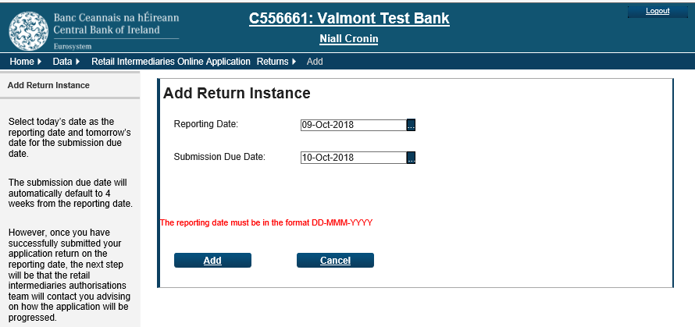
Figure 6
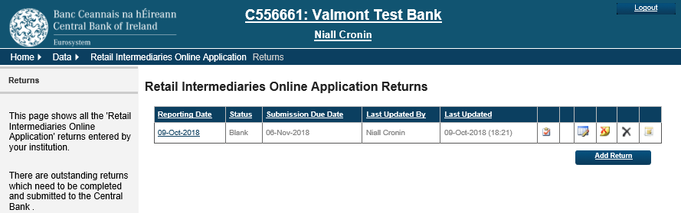

  - The most recent return will appear at the top of the screen, see Figure 6 above. Please note that the ‘Reporting Date’ and ‘Submission Due Date’ will be set from the first date that the applicant creates the return and will not change. The applicant can edit the return on future dates before submitting it to the Central Bank. Please also note the available solutions when you hover the mouse over the icons on the right hand side of the each return e.g., ‘Validate Return’, ‘Edit Return Status’, ‘Clear Return’, ‘Delete Return’ and ‘Create a Request’ (). See Figure 7 below.
Figure 7

  - Click on the ‘Reporting Date’ for the return that you wish to edit. This will being you to the page for that return, see Figure 8 below.

Figure 8
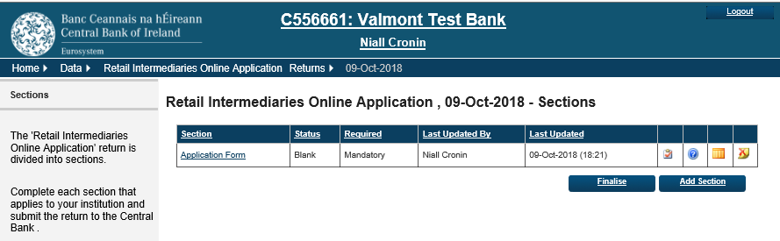

Upload the Application Form and the Relevant Supporting Documentation
  - In the ‘Sections’ page, the ‘Retail Intermediaries Online Application’ is in one section. Click on ‘Application Form’ under the ‘Section’ heading. See Figure 8 above.

  - In ‘Application Form’ files, the applicant can add the relevant application documents by clicking ‘Add file’. Add each file separately, selecting the document type from the drop down list provided. Please note that the ‘Application Form’ must be uploaded first as this document is mandatory. When adding the ‘Application Form’, please tick the box if the firm is applying for authorisation as a sole trader/single director company. Please review the other documentation types, adding whichever documents are applicable to the applicant’s application. Click ‘Other’ if the document you are adding does not match the other options provided. See Figures 8 and 9 below.

Figure 9
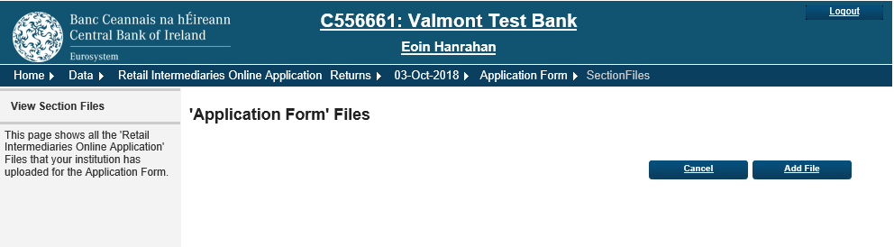

  - Please upload the documents using the ‘Browse’ facility, see Figure 10 below.

Figure 10
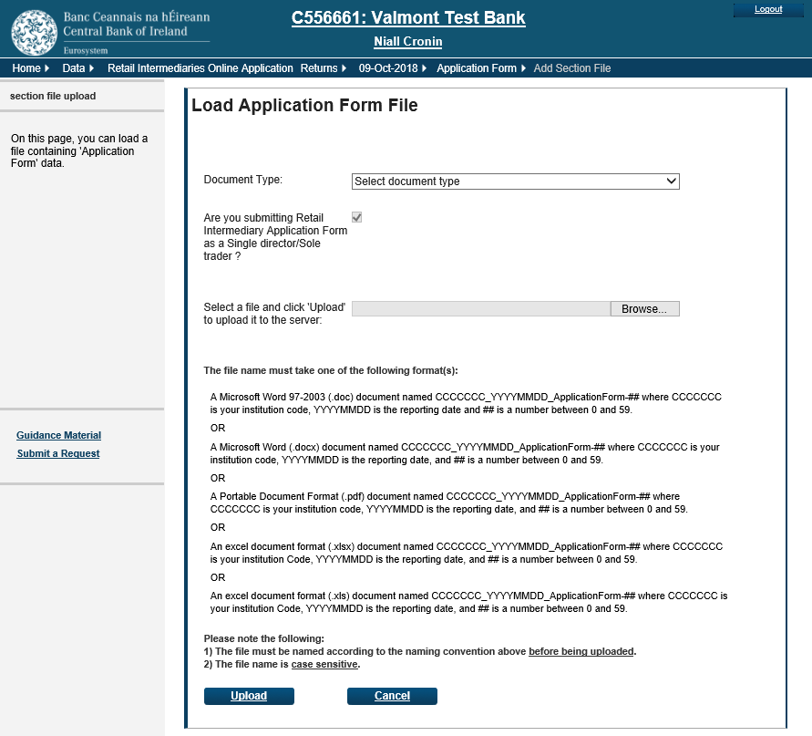

  - Please note that, before documents can be uploaded, they must be named and formatted following the on-screen instructions (using the firm’s ‘C’ number, relevant reporting date, number of files etc.).

For example,
- the ‘Application Form’ could be named C123456_20181003_ApplicationForm-1,
- the ‘Organisation Chart’, could be named C123456_20181003_ApplicationForm-2 and so on.
The firm will receive an error message if the files are not named correctly.
Click ‘Upload’ at the bottom left hand side of the screen when you have selected the correct file. Once uploaded, if you wish to delete a file, please click X at the right hand side of the screen. See Figure 10 above.

Figure 11 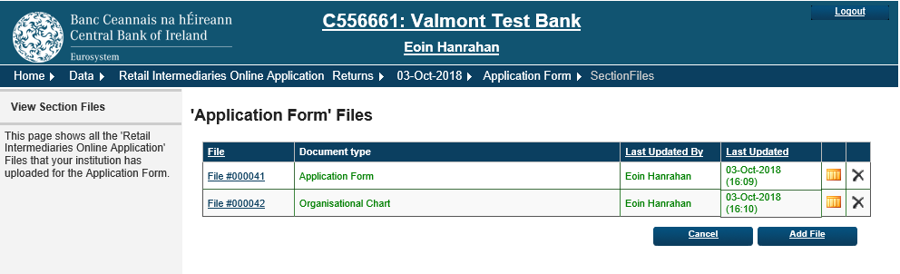

  - To finalise the return, click the return date at the top of the screen to the right of Home, Data etc. (in this case, 03-10-2018) and click ‘Finalise’. See Figure 12 below.

Figure 12

Before finalising, if you wish to go back to add another file, click on ‘Application Form’. See Figure 13 below.
Figure 13
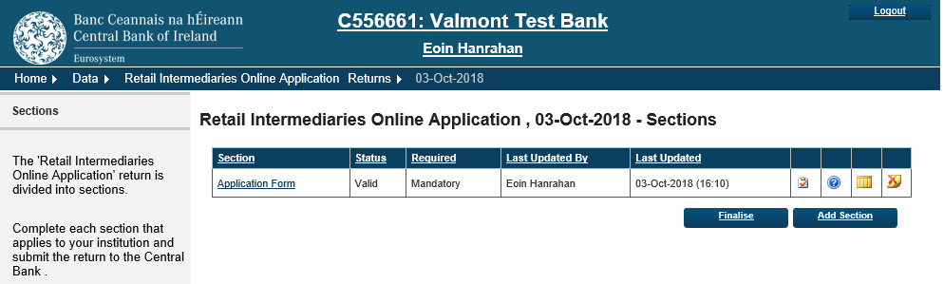

Submit the Completed Return
  - If the applicant is a sole trader or single director company, you will be asked to navigate to the previous page to sign off. Click ‘Sign Off’. Please read the text on-screen, noting that the Submission Due Date is irrelevant for this return. Please tick the box to accept the statement and click ‘Sign Off Return’. You will receive on-screen, and via an e-mail, confirmation that the return has been successfully submitted. See Figures 14-17 below.

Figure 14
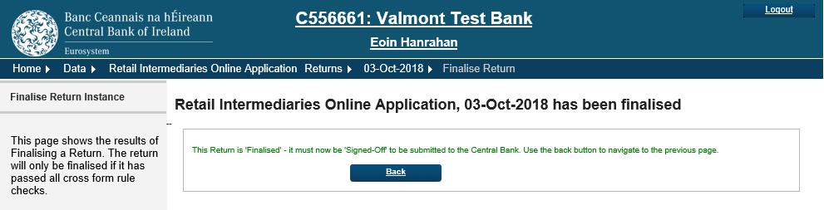

Figure 15
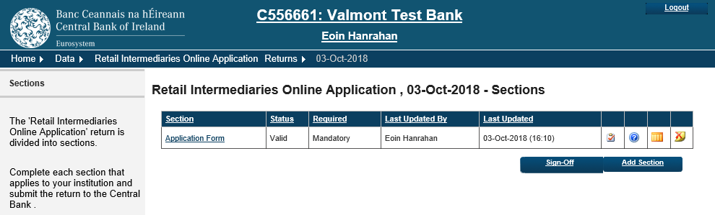

Figure 16
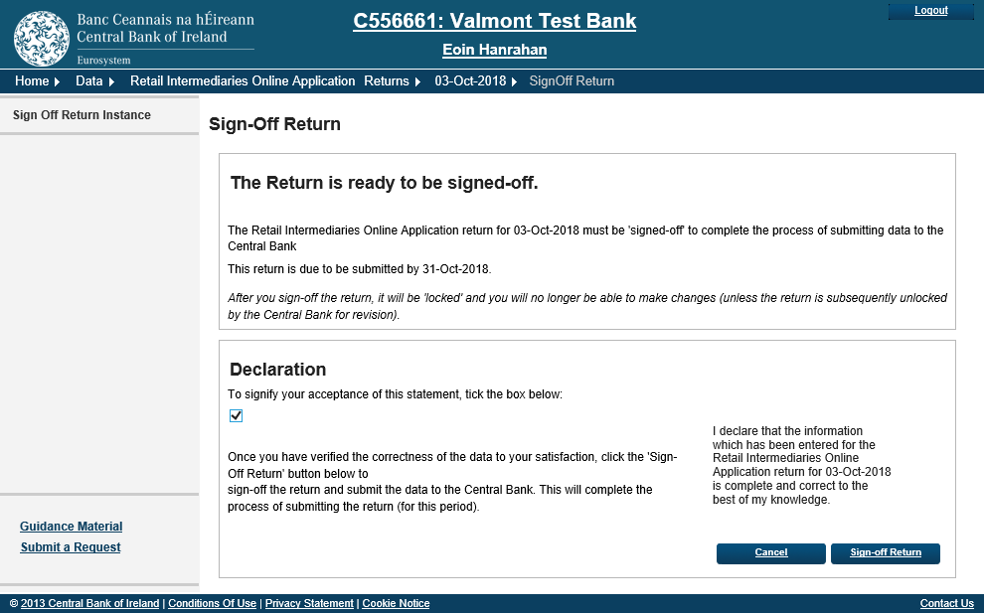

Figure 17
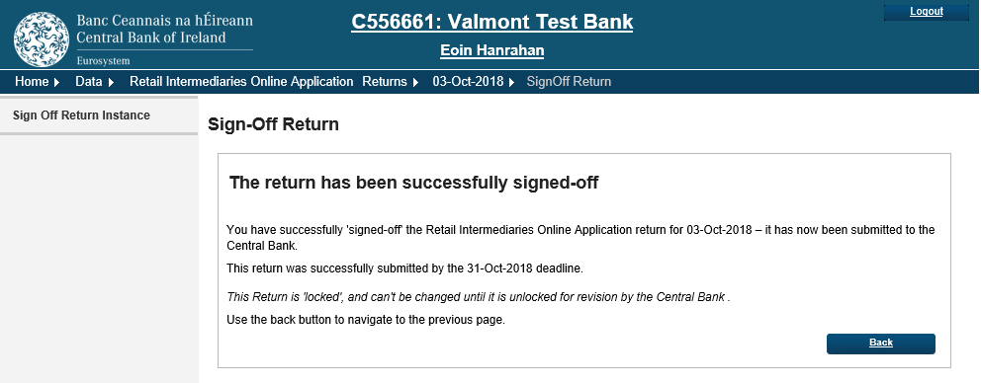

  - If the applicant is not a sole trader or single director company, another director/partner must log in to the ONR, instead of clicking ‘Add Return’, click on the reporting date of the return that you wish to sign off. This return should have a status of ‘Finalised’.
  - Online IQs in respect of proposed PCF role holders in the applicant must not be submitted at this time. The Retail Intermediary Authorisations Section will contact the applicant once a key information check has been carried out in respect of the applicant’s application. Please review the key stages of the application process (i.e., Acknowledgement, Key Information Check, Submission of Individual Questionnaires, Assessment, Notification of Assessment/Decision) on the Retail Intermediaries Authorisation Process page of the Central Bank’s website here).
  - During the application process, the applicant may have to make multiple submissions to the Central Bank including documentation that has been amended. Additional submissions must be made under new returns. Please follow the instructions above in respect of each subsequent return, noting that all application documentation must be submitted with each return.

List of Statuses
The following describes the different types of status that can be assigned to a status.
Blank | No entries have been made on the return
Incomplete | The application return is incomplete as no files have been added
Valid | The firm has added files to the application return and it is ready to be finalised if no other files need to be added
Finalised | The application return is finalised and is ready to be signed off
Signed off | The application return has been signed off and successfully submitted to the Central Bank

T: +353 (0)1 224 4595
E: RIAuthorisations@centralbank.ie
www.centralbank.ie

