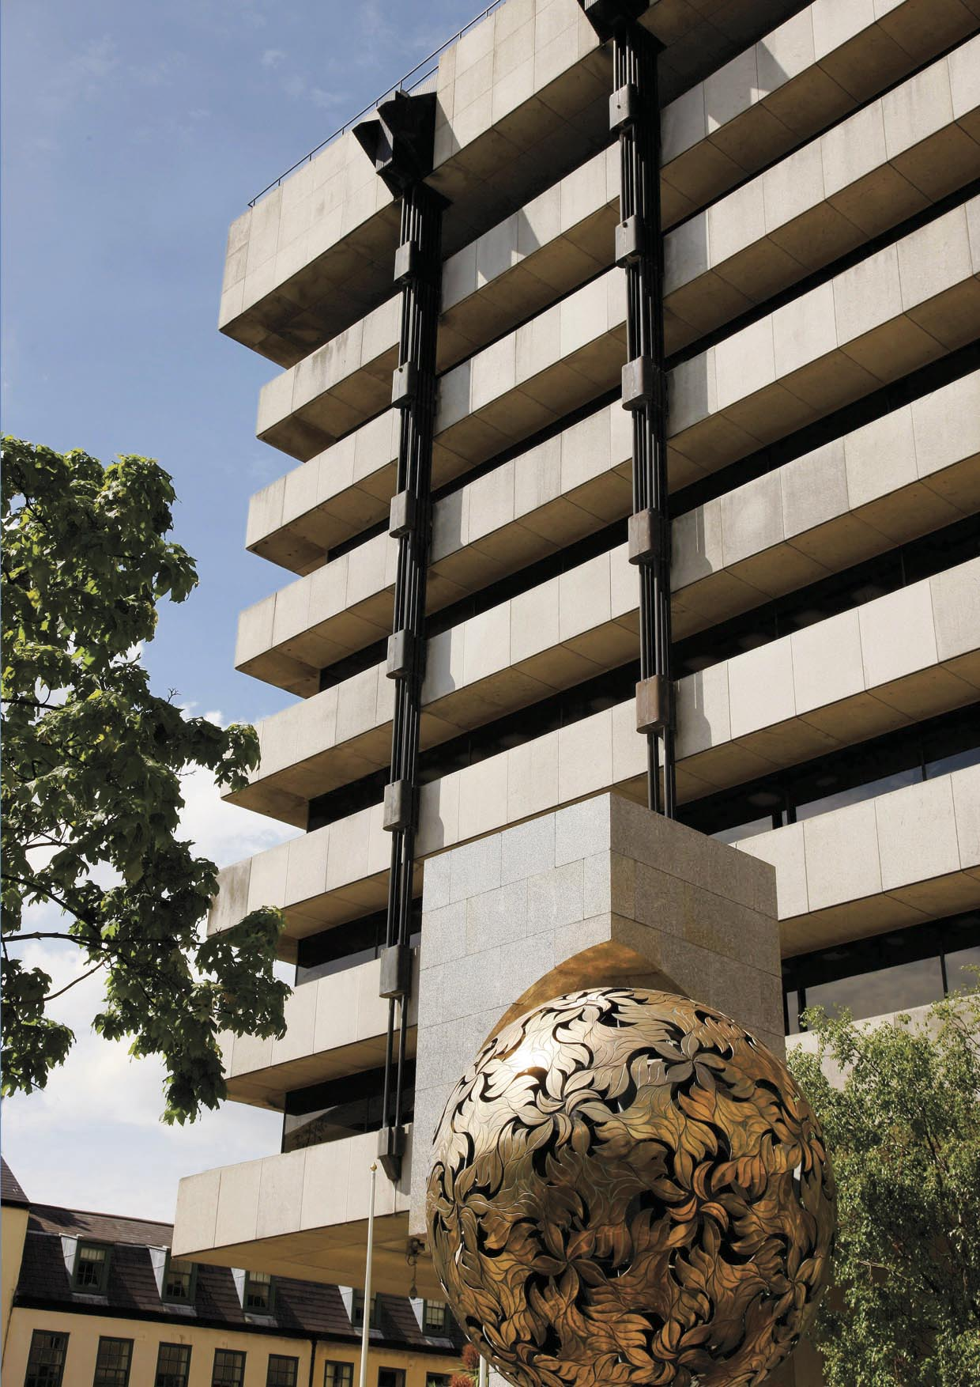
Application for Revocation of Authorisation as a Bureaux de Change Business
Under Part V of the Central Bank Act 1997 (as amended)
2017
Instructions for Completion

NB: It is important to ensure that all applications are complete. Incomplete applications will result in a delay in the processing of the revocation and may expose the firm to continued regulatory levies or other levies by reason of the delay. Failure to complete the voluntary revocation process after it has been initiated may result in the Central Bank of Ireland (‘the Central Bank’) commencing involuntary revocation procedures against the firm. Should such action become necessary, the failure by the firm and the persons concerned in its direction and management to co-operate in the voluntary revocation of the firm’s authorisation/registration will be viewed negatively by the Central Bank and the Central Bank reserves the right to take such regulatory action as may be appropriate in respect of such failure. It is the responsibility of the firm to ensure compliance with all obligations imposed on the firm under Part V of the Central Bank Act, 1997 (as amended).

Personal Data
The Central Bank may process personal data provided by you in order to fulfil its statutory functions or to facilitate its business operations. Any personal data will be processed in accordance with the requirements of data protection legislation. Any queries concerning the processing of personal data by the Central Bank may be directed to dataprotection@centralbank.ie. A copy of the Central Bank’s Data Protection Notice is available at www.centralbank.ie/fns/privacy-statement.

Please complete all sections of the Application Form

Section 1

Name / Name of Firm: _______________________________________________

Central Bank Reference Number: C_______________________________________

Address of Firm: ______________________________________________________ ____________________________________________________________________

Contact Person Name: _______________________________________________
Contact Person Telephone Number: ______________________________________
Contact Person Email: _________________________________________________

Please confirm the following by placing a tick or “yes”, as applicable in the column of boxes
1. | I hereby confirm that I am not aware of any legal or regulatory issue regarding the firm that should be brought to the attention of the Central Bank of Ireland prior to the firm’s revocation.
2. | In relation to any complaints to the Financial Services Ombudsman (“FSO”) concerning the firm that may be in existence or that may arise in the future, I confirm that the firm will co-operate fully with the investigation and adjudication of any such complaints.
3. | I confirm that the identity and contact details for the person who will be assigned to deal with any such complaints to the FSO are set out below and I consent to the Central Bank disclosing these details to the FSO:  Name of Contact Person: _______________________________  Contact Address:_____________________________________  _____________________________________  _____________________________________  Contact Person Telephone Number: _____________________  Please note that the firm will remain liable for all applicable Industry Funding levies, etc, until such time as its authorisation has been revoked.
4. | I can confirm that the firm’s website (or sections relating to regulated business) have now been de-activated  OR  The website or relevant sections will be de-activated before the firm ceases to act as a regulated entity
5. | I can confirm that all liabilities, duties and obligations of the firm have been/will be discharged in due course.

Declaration

I confirm that the information provided in this form is true and accurate and I am duly authorised to apply for revocation of the firm’s authorisation.

Name (in print): ______________________________

Signed: ________________________________

Date: ________________________________
Section 2

1. | I hereby request cancellation of the firm’s authorisation as a Bureaux de Change in accordance with Section 36 of the Central Bank Act, 1997 (as amended).

To reduce hard copy filing within the Central Bank, we request that a scanned copy of the completed form and any relevant attachments be sent to the e-mail address below.

If the firm does not have access to a scanner, hard copies will be accepted by post.

Please direct revocation queries to: revoke@centralbank.ie.

Revocations
Consumer Protection: Policy and Authorisations
Central Bank of Ireland
P.O. Box 559
New Wapping Street
North Wall Quay
Dublin 1

T +353 1 224 4000 F +353 1 2244565 www.centralbank.ie revoke@centralbank.ie

If you are aware of any such legal or regulatory issue, please set out details of this separately.

