Data Validations
PSD2 Major Incident Reporting

The Central Bank is implementing new data validations for the PSD2 major incident reports. PSPs (payment service providers) can continue to upload the reports as usual on ONR (online reporting system).
Under the new data validations, incomplete or incorrect reports will not be able to be uploaded to ONR. When an error is detected, the ONR user will be informed in ONR that the file has been rejected:

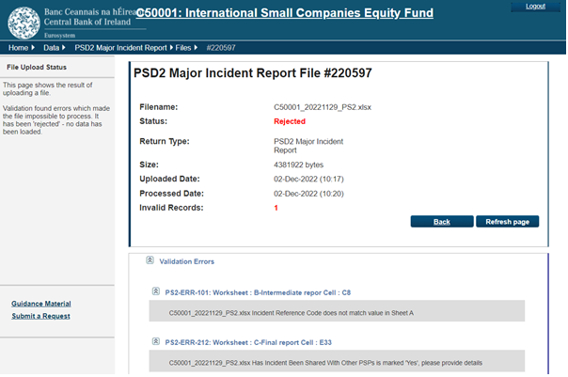
An automated email with details of the error will also be sent to the ONR user.
The error message will detail:
- The sheet (either Initial, Intermediate or Final) the error is on e.g. B-intermediate report;
- The cell within the sheet that contains the error e.g. Cell C8;
- A description of the error, e.g. Incident reference Code does not match value in Sheet A;
- The relevant error code e.g. PS2-ERR-101

PSPs must correct the errors before the files can be uploaded to ONR.

Examples of data validation rules and common issues:
- Report date must be completed;
- PSP name must be completed;
- Incident reference code must be entered and the same code should be used throughout all reports for the same incident;
- ‘If Yes, please specify’ or ‘If Other, please specify’ – where a dropdown box is answered ‘Yes’ or ‘Other’ etc. the relevant comment box must also be completed.

See also the PSD2 major incident reporting guidelines on the Central Bank’s website:
https://www.centralbank.ie/docs/default-source/regulation/psd2/psd2-major-incident-reporting-guidelines.docx?sfvrsn=38efbb1d_2

The EBA’s guidelines on PSD2 major incident reporting:
https://www.eba.europa.eu/regulation-and-policy/payment-services-and-electronic-money/guidelines-on-major-incidents-reporting-under-psd2

RADAR
February 2023

